Athens Inclusive Education Training
Inclusive Education Project
Jake Delatolas-Saveris

The Inclusive Education Project was implemented with a group of 17 learners who are in Year 9 during the 2023-2024 Academic Year and the subject is English. The Project incorporated six steps.
Step 1. Identify Learner Characteristics & Barriers
Existing Barriers The learners generally do well. However, there are 6 of them who often struggle with new vocabulary items. Two of the six have been diagnosed with dyslexia and ADHD.
Learner Strengths Eleven of the learners are really strong and hard-working. They submit assignments on time and enjoy doing work. They take in new vocabulary easily and use new vocabulary items in example sentences. All of them like educational technology and are motivated when using it.
Learners Weaknesses The six learners mentioned above are reluctant to try harder and they get easily distracted. They avoid doing homework and rather dislike the idea of taking down notes.
Learners Preferences/Interests All learners love educational technology. They prefer using handheld devices in the teaching/learning process to writing on a piece of paper.
Step 2. Develop Goals and Learning Objectives of the Intervention
During the intervention the learners will be able:
- to find the meaning of new vocabulary items on their own using online dictionaries.
- to learn the meaning of new vocabulary items by studying them in example sentences.
- to use new vocabulary items in paragraphs they produce on their own.
Step 3. Develop Assessments
The assessment designed for the intervention is threefold. In the pre-assessment, we can measure how difficult it is for the learners to understand new vocabulary items by playing a game on Kahoot (with the new vocabulary items) before teaching the vocabulary items to the learners. In the formative assessment, we can monitor the learners’ progress by having them use the new items in a paragraph which is posted on Padlet. In the summative post assessment, we can demonstrate any changes in the issue by having the learners take a quiz on Microsoft Teams with the new vocabulary items.
Step 4. Develop Teaching Materials
The strategy chosen to implement the intervention is Blended Learning. The group of 17 students in Year 9 are using the textbook HMH Into Literature Grade 8 this year, and they have reached Unit 5. While reading the informational text The Debt We Owe to the Adolescent Brain, the learners will be presented with 10 new vocabulary items from the text in class, and they will try to guess the meaning of them from the context while playing a game on Kahoot with these items (in order to motivate them and challenge them at the same time). The homework that they will be assigned on Blackboard is to look up the meaning of these items on online dictionaries, and check if their guesses were correct. Also, they will study the example sentences provided on online dictionaries at home.
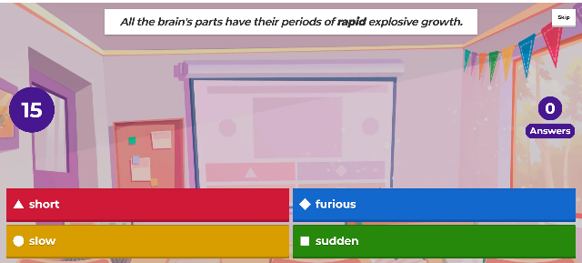
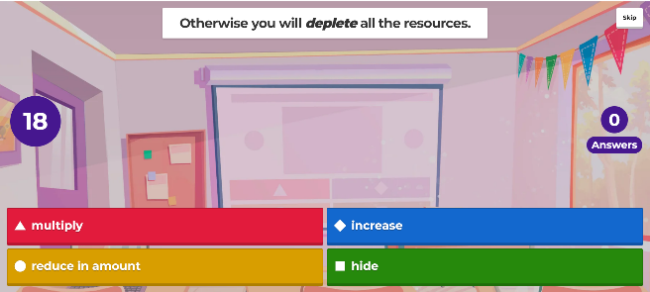
In the next lesson, they will use their handheld devices to write a paragraph on Padlet in class, using any eight of the vocabulary items. Feedback will be provided to them on Padlet, which they will read at home. When the learners have finished studying The Debt We Owe to the Adolescent Brain, they will take a vocab quiz on their handheld devices on Microsoft Forms so that they can be given instant feedback on their performance. Hopefully, even the less motivated learners who struggle with vocabulary will have made some progress.
Step 5. Teach
While implementing the plan in the classroom, it is evident that the learners are really engaged and eager to participate. The fact we have not used Kahoot before makes them obviously excited. The element of the competition and the fact they are using their mobile phones keeps them focused on the activity. The pieces of writing they produce on Padlet are original and they use the vocabulary items successfully.
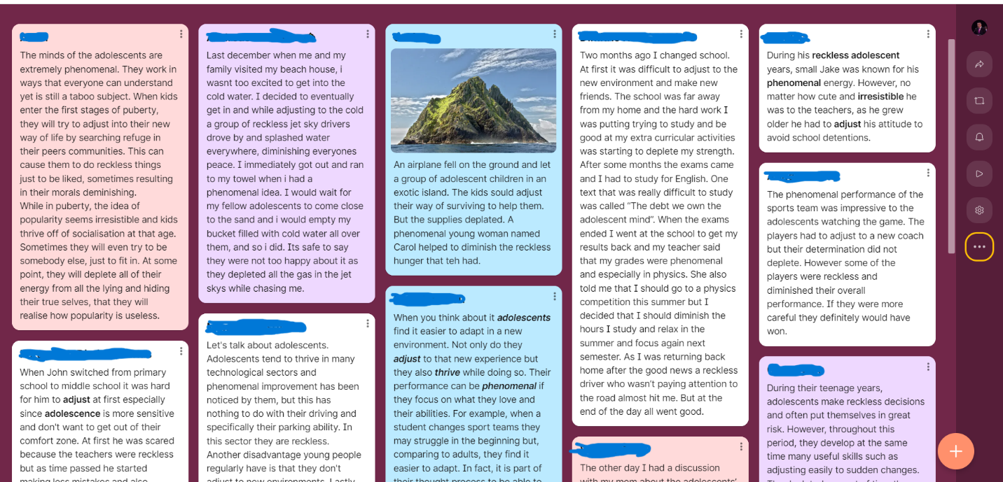

At the end of the second period, I ask them to write down their opinions.
I am sharing some of their comments:
(#1) “I believe that learning vocabulary with Kahoot or Padlet is a much more entertaining and fun way of doing it. You actually want to learn as this method combines technology and education.”
(#2) “Using Kahoot and Padlet to learn new vocabulary is an innovative idea and definitely appealing to teenagers.”
(#3) “Kahoot was a fun, interactive way of understanding the meaning of a word in context. But when I had to write the paragraph on Padlet it really put my knowledge into practice.”
(#4) “Using Kahoot and Padlet for vocabulary exercises made the lesson more entertaining and it made me remember the unknown words way more easily.”
(#5) “I think students pay more attention on Kahoot because if they get distracted they immediately lose.”
(#6) “Kahoot makes the lesson more fun and because of this it’s easier to concentrate and participate in the things we do.”
(#7) “Learning vocabulary with Kahoot and Padlet really helped me understand the words. Kahoot was fun and competitive. We should do it more.”
(#8) “I think that Kahoot definitely made learning more fun and if every lesson was like this, I would be looking forward to English lessons.”
Step 6. Reflect
Having completed the project, I firmly believe the intervention did change the learning outcomes. The learners I wanted to motivate most of all while brainstorming about the project were really inspired, and I believe their comments are encouraging. They did not struggle at all; on the contrary, they did their best along with the rest of the learners, and did well on their quiz as well. I guess there is always room for improvement and now that the academic year is over and we are planning next year’s courses, Kahoot and Padlet will be used more.

