



Athens Inclusive Education Training
Inclusive Education Project

Just for a little context my name is Mrs Lucy Hudson Christidis, I am English but moved to Greece after my marriage to a lovely Greek gentleman. After gaining a Bed/BSc Honours Technology Education and Qualified Teacher Status at the University of Sunderland, I taught in the UK, Design and Technology to Key Stage 3 (Resistant Materials, Graphics, Food & Textiles) and specialised in Graphic Products at Key Stage 4. My first teaching position, after moving to Greece, was the school Nea Genia Ziridis where I taught Technology to the Gymnasium and lower school children.

I moved to the American College of Greece in 2017, where I initially taught Technology to the Gymnasium students. After the recent opening of the lower school, I am now in charge of the Fab Lab/Makers Space lessons for the Kindergarten and Dimotico students. Lessons are taught in both English and Greek which is both a challenge and opportunity for the children. The Makers Space/Fab Lab facilities enables a multitude of outcomes to our design-based projects and focused activities but creativity and problem solving can be achieved with the most basic of materials and facilities.

My intervention plan, aims to address a reluctance or perceived inability to participate in classroom discussion’s and analytical feedback. There are of course students who enjoy the opportunity to express their opinion, understanding and experiences, however many students feel more confident within a group feedback situation or when they have been guided by a peer’s example. Most of the children will raise their hands in a yes/no (limited options) question but some children are reluctant to share their input due to fear of being judged by their peers. This could be a self-perceived lack of vocabulary or understanding also different backgrounds and experiences can make the student unsure of how their opinions will be viewed by their classmates.
The children are building their knowledge and capability through the different tasks and projects they are given; some prefer to work individually but most prefer to tackle the projects in groups, enjoying the camaraderie. In order to extract a more conclusive result from my intervention, I decided to introduce it into two full year groups, which means that I now have analysis gathered from eight Fab Lab/Makers Space classes.
The children were given an introductory lesson just before the Easter break, to help them decide how to feedback to the class. They were given as many options as possible to allow freedom of expression and the opportunity to present in the way they feel comfortable. The choice board and details from the lesson was uploaded onto the Teams platform so that the children had access to the work from home.

During the introductory lesson participation was observed and recorded using the program Clipchamp, which was also used as part of the demonstration section of the lesson. What was confirmed from looking over the lessons is the small percentage of students in each class, one or two, who can be relied on to volunteer to take part straight away. When it became clear that participating was not challenging, more children volunteered to read short passage and answer brief questions. However, it was the same students each time, with the majority content to observe, only with closed questions did the majority take part.
The assignment requires each student to report back to the class, they could decide to analyze what went well and where improvement could be made or focus on what they enjoyed most and what they learned. They were given the two-week Easter break to prepare their own one-minute presentation; if they chose to work in groups they each still needed to present for one minute (e.g. a group of three would need to present for 3 minutes).
The recording sheets I used during the class presentations allowed me to take notes easily and give positive feedback, whilst highlighting possible areas for development. The children had an egg timer to help them visually manage their time and their capability could be assessed at the same time
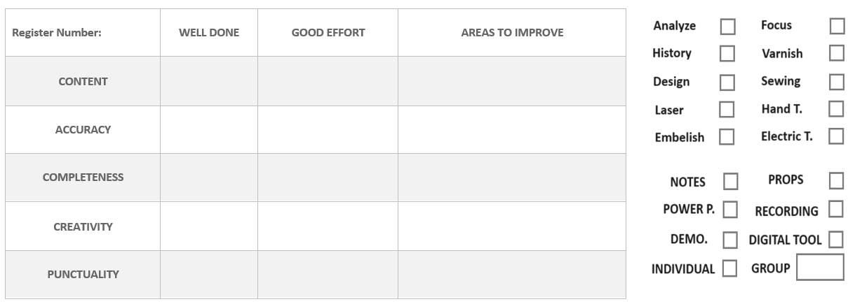
The format was shared with the students during the introductory lesson so that they are aware of the criteria in advance. For many this was the first time presenting, so the emphasis was put on developing their capability and confidence and therefore they were given feedback, rather than being graded.
• Content – How well do you show what you have learned?
• Accuracy – Do you show correct information?
• Completeness –Were all requirements met?
• Creativity – Did you demonstrate your individuality?
• Punctuality – Was the work ready on time?

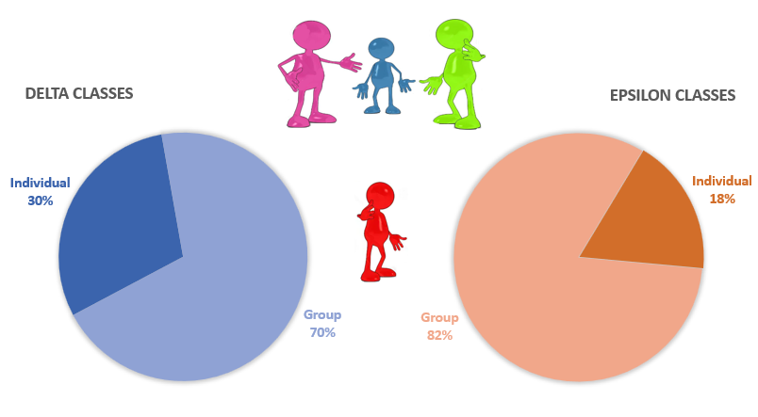
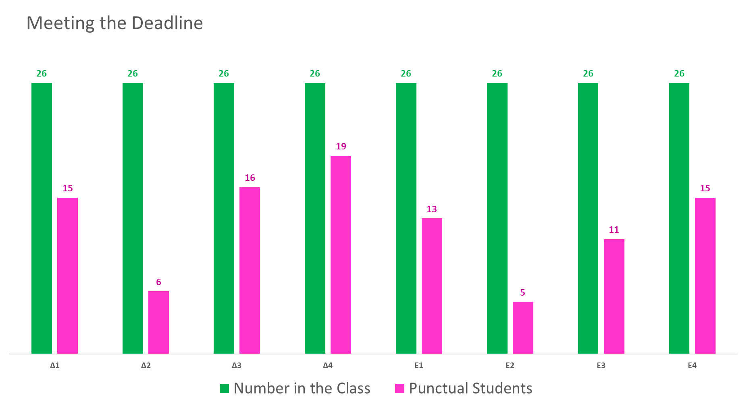
This was the first time many children had prepared a formal presentation and so it was not surprising that half of the children did not come prepared to present the first lesson back. This may have been accentuated by the age group, who are still developing their organisational skills. The children were verbally reprimanded for this and it was recorded in the register (to foster accountability). However, the emphasis was on praising the punctual children and learning from their mistakes. All of the students (exempting absences) took part in the end; there were some students still unprepared the second lesson but they were given a private corner to collect their thoughts and make notes, so that everyone could participate. Again, the emphasis was not what they had done wrong but how much more confident and relaxed they would have been with a little more preparation.
The majority of children decided to present within groups of two to five children, which was not surprising. What I did not expect, was that the number of individual presentations almost halved in the older age group. This may be due to increased peer group pressure or greater social bonds but it was a noticeable trend.
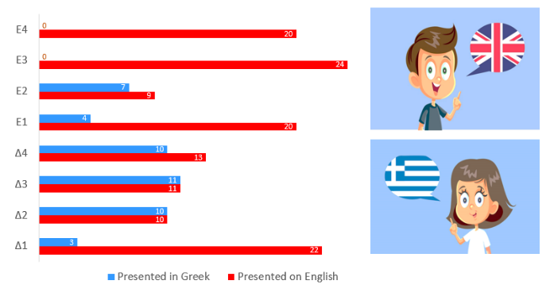
The children were free to use either their native tongue or mine, so I was pleasantly surprised in the number of children who decided to present in English. During my lessons I communicate with the children in both languages and leave it up to them, how much they take advantage of the extra exposure. I always tell them that as my subject is not graded they can use whichever language is most comfortable, it is just an opportunity to put their learning to practical use.

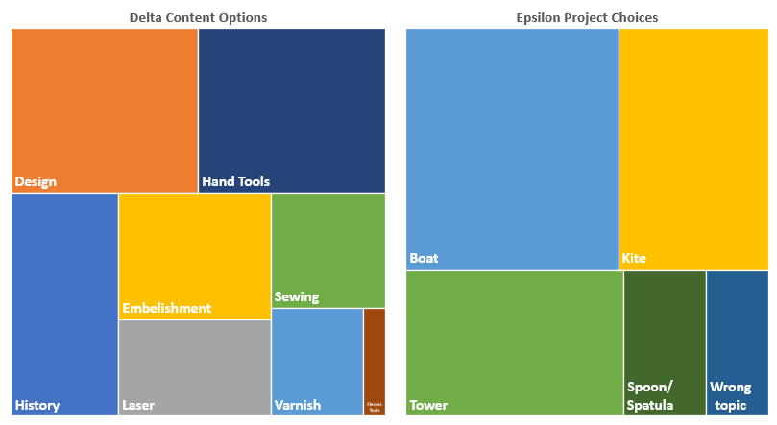
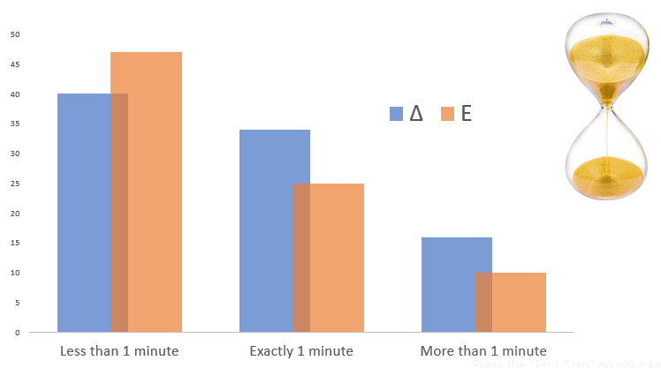
Time management is skill that the children still need to develop as the majority had not prepared enough information. There were of course children who had done much more than was required. It was noticeable that the children, who used the digital tools option managed this criterion with ease. It became a game to see who could use the time precisely, which appealed to the more competitive students. The children with sand remaining in the hour glass were encouraged to fill the time with extra feedback, they found this difficult but it was important for them to understand the difference they felt when delivering prepared and unprepared information. The children who overshot the time limit, were praised for their hard work but given advise on how to manage their time and industry more effectively.
The breakdown of chosen topics showed both how the projects were weighted and the enthusiasm for each part. In the Delta Trireme project, the children enjoyed using the coping saw and vice to cut out the wood but they were forced to extend their design capabilities as they could not continue with the project, without completing the minimum requirement of each stage. Learning to consider different options and produce more than one solution is a new concept, to most of the students. With the Epsilon classes the most recent project took the majority of the focus as it was still fresh in their minds. However, the ones who had particularly enjoyed specific projects gave excellent, insightful feedback as the topic had stuck a cord with them, either for the outcome or process of the project. Only one group misunderstood the task and presented information about butterflies, this was an easy topic to connect to the kite project, so it was an opportunity to show the children how parallels could be drawn.
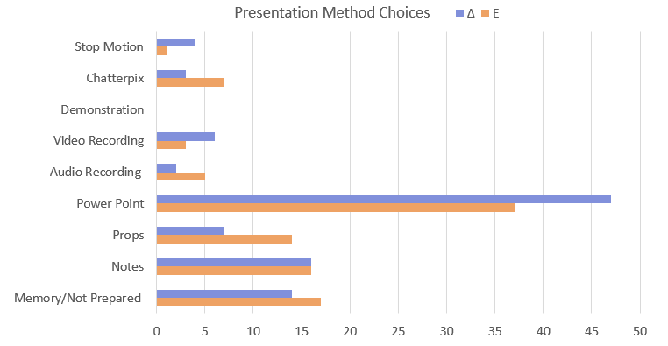
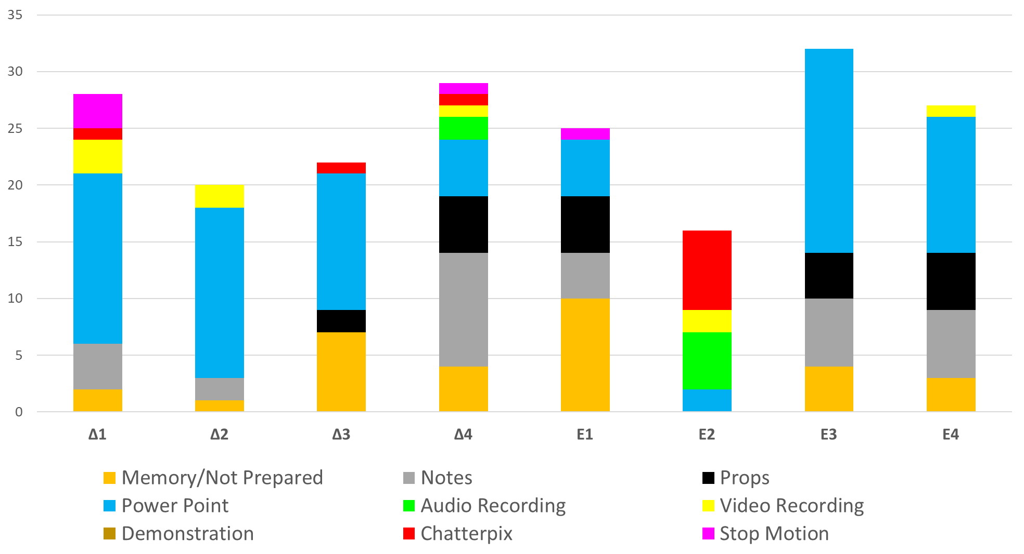
What I anticipated most was the method the children would choose for their presentations. During the introductory lesson it was clear that the majority had some experience with Power Point but they were interested in the newer options too.
Although the overall figures showed a preference for a tried and tested format, the individual classes were highly influenced by what they saw in the first round of presentations.
The students in the E2 class opted, in the main, for the newer digital tools used by the children in the first session. Unfortunately, a few missed lessons and student absences in this class did not give all the students the opportunity to present their work; I would time this differently in the future to avoid such conflicts.

Regardless of the method chosen there was a learning opportunity for both the individual student and the class as a whole. This was an important milestone for many of the children as they had not presented in front of the class before. They also needed guidance on how to observe and interact, only positive comments were expectable. The choices, I believe, did make it easier for the students to be more productive and confident.
Firstly, when you are presenting the exact same topic, in the same format, it can quickly become repetitive and the class will lose interest. The children were engaged and interested for each of the presentations - even when the subject was the same, the focus or method of delivery was different. Of course, there were those who had dedicated more time and care into the work and this was praised and highlighted but regardless the quality and quantity, at the end of each presentation the feedback was always how to improve – this is the key goal of my lesson, solving problems and continual improvement, so I may be a little bias here.
There were also some students who were very nervous before and during the presentation, even a few tears. These individuals were given time and encouragement and all felt a lot better after they had taken their turn. There were some students who are normally shy to take part in class, that took advantage of the opportunity to take part remotely by recording their presentations with one of the digital tools – they were noticeable more confident than normal.
Some pieces of work obviously had help from home but this will always happen with any type of homework and if the parents have the time to impart their experience and knowledge both the family and class will be richer for the outcome. The focus of this work was to address a reluctance or perceived inability to participate in classroom discussion’s and analytical feedback - the preparation that was done made this easier for the child but they learned as much through observing their peers as they did from taking part themselves.
This intervention ensured that all the students took part in the analysis and review section of the work. I had not asked for a formal piece before in this age group, as I assumed that it would be too challenging for them. There was a wide range of presentations, content, quality and methods used but all of the children took part and learned from it. I would only use this once a year as I am tightly restricted on time and this requires a minimum of three lessons but the outcome validated the time required. I would also schedule this differently as while the extra time provided by the Easter Break is beneficial to older children, the organisational skills of the younger students means the normal week in between classes, could decrease the number unprepared.
Overall, I was very happy with the outcome of this intervention and will definitely make it part of the curriculum in the future, the choice board proved to be a valuable learning tool that could also be implemented into other sections of the work that I do.

