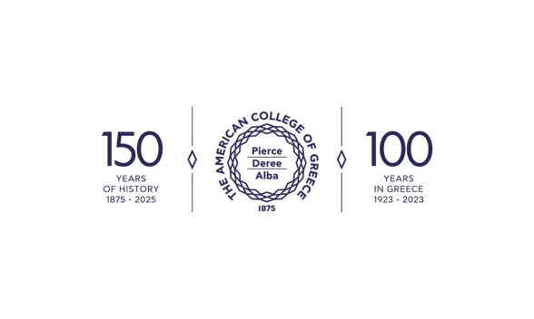


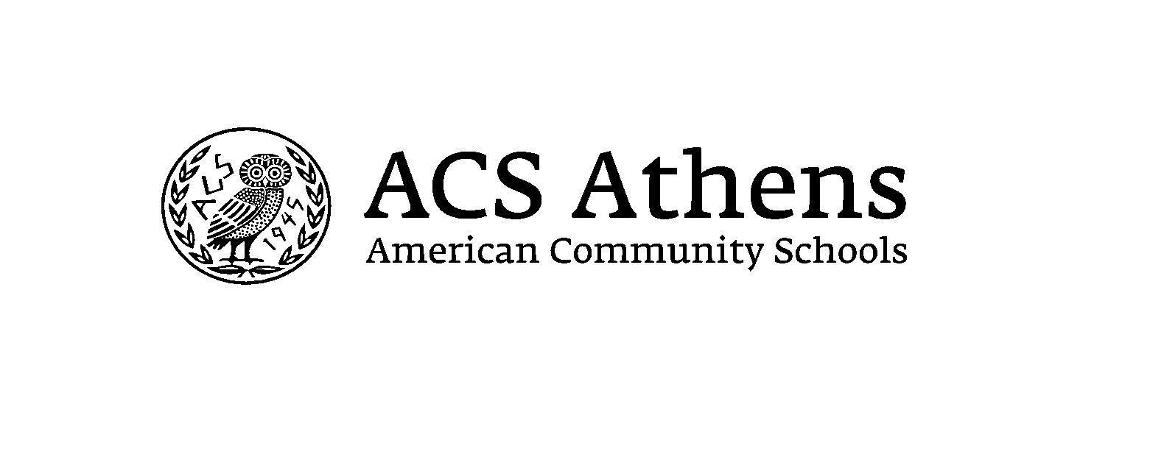

Athens Inclusive Education Training

Little Music DIY Orchestras

The "Little Music DIY Orchestras" lesson is a dynamic and interactive musical experience designed specifically for fourth-grade students, aiming to foster creativity, collaboration, and inclusivity in the classroom. The main objective is to empower students to take ownership of their learning by selecting instruments they prefer and collaborating with their peers to create, perform, and experiment with music. Once students have selected their instruments, they work together in small groups to form their own "DIY Orchestras." Guided by the teacher, students collaborate to explore different musical genres, styles, and techniques, experiment with sound production and manipulation, and construct original musical compositions. Through hands-on exploration and experimentation, students develop their musical skills, creativity, and confidence as they work towards creating their own unique musical constructions.
One of the key pillars of this lesson is inclusivity, ensuring that every student feels valued and included regardless of their background, abilities, or musical experiences. By offering a wide range of musical instruments and technology options, the lesson accommodates diverse learning styles and preferences, allowing each student to find their unique voice and role within the orchestra. In addition, the collaborative nature of the lesson encourages students to work together, share ideas, and support one another, fostering a sense of belonging and mutual respect in the classroom community.
Moreover, the "Little Music DIY Orchestras" lesson emphasizes differentiation to meet the individual needs and abilities of all students. Teachers can provide scaffolded support and guidance as needed, tailoring instruction and activities to accommodate varying skill levels and learning paces. For example, students who are new to playing musical instruments may receive additional coaching and practice opportunities, while those with prior experience can take on leadership roles and mentor their peers. Furthermore, the lesson encourages students to experiment and construct music in their own unique ways, fostering a growth mindset and celebrating the diversity of musical expression within the classroom.
Overall, the "Little Music DIY Orchestras" lesson offers a rich and inclusive learning experience that empowers fourth-grade students to explore, create, and connect through music. By embracing diversity, collaboration, and differentiation, this project not only cultivates musical skills and knowledge but also promotes valuable life skills such as teamwork, communication, and self-expression. Whether they are playing familiar pieces, composing their own music, or experimenting with music technology, students are encouraged to take risks, make mistakes, and learn from their experiences. Through active participation in the DIY orchestra, and by providing a supportive and inclusive learning environment that values creativity, collaboration, and experimentation, the "Little Music DIY Orchestras" lesson empowers fourth-grade students to unleash their musical potential and cultivate a lifelong love for music..
Learner Characteristics & Barriers
Existing Barriers  - Misconceptions about Music: Some students may have misconceptions about music, such as believing that music is only performing or ignoring other musical praxis activities like producing, conducting, listening, composing, experimentation, etc. These misconceptions could hinder their willingness to explore and engage in different musical activities.  - Physical Barriers: Many young students may have difficulties in motor skills, which could present challenges in manipulating and playing certain musical instruments or equipment. Additionally, students with physical disabilities or limitations may require accommodations to fully participate in hands-on music activities.  - Social Barriers: Fourth-grade students may be particularly sensitive to social dynamics within the classroom. Peer pressure, fear of judgment, or a lack of confidence in their musical abilities could deter some students from actively participating in group music activities or sharing their ideas and creations with their peers.  - Ability Barriers: Fourth-grade students may have a wide range of musical abilities, from those who have had previous exposure to music lessons or experiences to those who are relatively inexperienced. | Learner Strengths  - Creativity: Improvisation, composing melodies, or creating unique arrangements with available instruments and resources.  - Auditory Processing: Identifying different timbres and musical elements and rhythms.  - Performance Skills: group performances can help students demonstrate what they've learned and build confidence in their abilities  - Collaboration: ensemble playing, creating compositions as a team, or providing constructive feedback.  - Hands-On Learning: Students actively engage with musical instruments, experiment with sound production, and manipulate musical elements to create their own musical artifacts, leading to an understanding of musical concepts.  - Critical Thinking: critical thinking skills cultivation by analyzing and assesning musical compositions, identifying patterns and structures, and making creative decisions about musical elements.
Learners Weaknesses:  - Difficulty with Abstract Concepts: complex abstract musical concepts such as rhythmic patterns, tonal relationships, or interpreting musical symbols and notation.  - Attention and Focus: struggle with maintaining attention and focus if the material seems difficult or if the lesson lacks variety and engagement.  - Fine Motor Skills: playing musical instruments that require precise movements or coordination.  - Limited Musical Background: limited exposure to music outside of the classroom, which can result in gaps in their understanding of musical concepts and terminology and struggle to make connections between new information and the existing knowledge base.  - Self-Expression and Confidence: hesitation about expressing themselves musically, particularly in front of their peers.  - Difficulty with Transferability skills: challenging to transfer musical skills and knowledge from one context to another.  - Limited Exposure to Diverse Musical Styles: limited exposure leading to narrowing musical preferences. | Learners Preferences:  - Musical Genres: diverse preferences for musical genres, including pop, rock, classical, jazz, hip-hop, or world music.  - Instrumental Preferences: preferences for specific musical instruments based on personal interests or experiences, while others enjoy singing.  - Technology and Digital Tools: keen interest in technology and digital tools, such as digital audio workstations or virtual instruments.  - Creative Expression: opportunities for improvisation, composition, and collaborative music-making can stimulate creativity and engage in active learning experiences.  - Cultural Diversity: interest in exploring music from different cultures and traditions, such as traditional songs, dances, or musical instruments from various cultures.

Goals and Learning Objectives of the Intervention
Learning Objective #1: Students will be able to demonstrate dexterity in playing at least one musical instrument of their choice within a small group setting.
- reflect critically on their own musical progress and performance skills, setting personal goals for improvement.
- showcase their accomplishments through a culminating performance or presentation for their peers or school community.
Learning Objective #2: Students will be able to collaborate effectively with their peers to create and perform a unique musical composition using a variety of instruments and musical elements.
- identify and describe the roles of different instruments and interpret them in their distinct musical notation system (e.g., graphic score).
- to demonstrate effective communication and collaboration skills during rehearsals and performances, including active listening, giving and receiving feedback, and respecting the contributions of their peers.
Learning Objective #3: Students will be able to articulate their understanding of basic music theory concepts, such as rhythm, melody, harmony, and form, through verbal explanations and written reflections on their musical experiences.
- actively listen to and analyze various musical compositions, identifying tempo, dynamics, instrumentation, and mood.
Learning Objective #4: Students will be able to demonstrate an appreciation for music as a form of creative expression and cultural heritage, recognizing its power to evoke emotions, communicate ideas, and bring people together across diverse backgrounds
- explore the cultural and historical significance of music from different time periods and regions, recognizing how music reflects and influences society, and identity.

Assessments
Pre-assessment:
- Survey or questionnaire: to collect data such as the preferred instruments, notation system, musical preferences, technology incorporation, interest in participating in music activities

Formative assessment:
- Observation and Feedback: During the lesson sessions, the teacher can observe students' progress following specific observation keys (motivation, focus, collaboration, creativity) in music praxis.
- Peer Assessments: peer feedback sessions where they provide constructive feedback to their classmates on their musical performances and compositions through one-minute-paper and 3-2-1 count technique at the end of the lesson.

Summative post assessment
- Performance Evaluation: musical abilities and progress through a culminating performance or recording, where they perform a piece of music individually or as part of a small ensemble, based on musical criteria (technical proficiency, musical expression, stage presence, and collaboration).
- Written Reflections: Students can write reflective essays and a short questionnaire reflecting on their growth and development as musicians throughout the intervention.

Universal Design for Learning (UDL)
My aim in incorporating Universal Design for Learning (UDL) into the "Little DIY Music Orchestras" music scenario is to foster an adaptable and all-encompassing educational setting that accommodates the distinct needs, preferences, and capabilities of all students. UDL acknowledges that learners acquire knowledge in diverse ways and highlights the significance of offering numerous avenues of presentation, involvement, and articulation to maximize educational achievements. Effective teaching materials will utilize a variety of modalities to present musical concepts and instructions. These may include visual aids, such as diagrams, charts, and videos, to demonstrate musical notation and instrument techniques. Auditory elements, such as recordings of musical compositions and instrument demonstrations, are also helpful. Additionally, hands-on experiences with musical instruments and equipment can provide valuable learning opportunities. By incorporating multiple means of representation, students of all learning styles and abilities can access and comprehend the content. To enhance student engagement, my focus would be on offering a variety of enriching learning activities that reflect their individual interests and motivations. Moreover, collaborative projects such as creating original musical pieces or arranging existing compositions foster teamwork, creativity, and a sense of ownership of learning. By providing ample opportunities for autonomy and choice in learning activities, students are more likely to feel enthusiastic and invested in actively participating in the lesson.
To cultivate a comprehensive and inclusive learning environment that fosters success in musical pursuits, I will implement multiple means of expression. This approach would entail presenting students with diverse options for demonstrating their understanding and skills, such as through performances, written reflections, visual representations (like graphic music scores), or digital multimedia projects. For instance, I would provide visual aids illustrating musical notation and instrument diagrams for visual learners, audio recordings of musical compositions and performances for auditory learners, and hands-on activities and interactive simulations for kinesthetic learners. Additionally, facilitating peer collaboration and feedback would allow students to learn from one another and enhance their communication and social-emotional abilities. To ensure equitable access to learning opportunities, I would also offer various options for students to demonstrate their understanding and skills, such as performance, composition, written reflection, and peer collaboration. By incorporating Universal Design for Learning (UDL) principles into instructional materials and practices, my objective is to create an environment that empowers all students and facilitates their growth and achievement in music.

