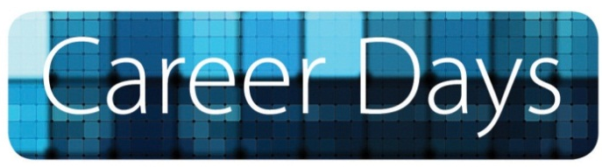

October 1 - 3, 2013

Tuesday October 1, 2013
A Strengths-Based Approach to Realizing my Potential (Workshop)
By OLN Learning
Discover how to develop a new positive mindset, the ways to discover your strengths, the role of inner talents
and how talents develop into strengths. Learn the principles and focus of positive psychology and use your talents and strengths to achieve goals and realize your potential.
Time: 11:00 – 14:30
Location: JSB Library, Library Conference Room
NOTE: Indicate your availability to attend; book your place soon as places are limited.

Career Coaching (Workshop)
By Career Coaching Professionals
Learn how to build your resume and cover letter and to perform well in an interview from an established company on guiding, preparing & supporting candidates in all stages of the Job Search process.
Time: 15:00 – 18:00
Location: JSB Library, Library Conference Room
NOTE: Indicate your availability to attend; book your place soon as places are limited.

WEDNESDAY October 2, 2013
Assessment Centers (Workshop)
By Adecco HR
Top companies are assessing the personality and aptitude of potential employees to recruit the best candidates. Be prepared & learn what Assessment Centers are all about!
Time: 10:00 – 11:30 & 11:30 – 13:00 (Two Identical Sessions)
Location: JSB Library, Library Conference Room
NOTE: Indicate your availability to attend; book your place soon as places are limited.

Company Visitation Day
Come and network with the leading companies in Greece. Talk with company representatives for current or future job vacancies and tailor your job search on the changing demands of the work environment.
Time: 13:00 – 17:00
Location: Student Lounge
NOTE: Bring copies of your resume

THURSDAY October 3, 2013
Career Building through Social Media (presentation)
By Stavros Papakonstantinidis
Adjunct Preceptor, Department Of Communication
Social Media platforms, such as LinkedIn, Facebook, and Twitter, have rapidly become major tools to develop new contacts and business opportunities. Yet, a vast majority of students and professionals struggles to get beyond the basics. Understand the emerging landscape of social media and obtain a practical guide to set up your personal and professional profiles to develop your business networks.
Time: 10:00 – 11:00
Location: 7th Level Auditorium

Company Visitation Day
Come and network with the leading companies in Greece. Talk with company representatives for current or future job vacancies and tailor your job search on the changing demands of the work environment.
Time: 11:00 – 15:00
Location: Student Lounge
NOTE: Bring copies of your resume

Body Language - What vibes are you giving off in an interview? (workshop)
By Forward Consulting
Learn what recruiters perceive through your body language, the do’s and don’ts in a job interview.
Time: 15:00 -16:30
Location: JSB Library, Library Conference Room
NOTE: Indicate your availability to attend; book your place soon as places are limited.

Important Information
- To register for the Workshops please contact the Office of Career Services by September 26, 2013 (TH)
- The list of companies participating in Company Visitation Days will be announced during the week of September 23-27,2013
- To participate in Company Visitation Days you only need to bring copies of your resume to the event.
- You are kindly requested to send a copy of your resume at career@acg.edu using as e-mail subject CareerDays.
- You are advised to dress formally on Company Visitation Days.
Student Arrival Time on Company Visitation Days:
- Wednesday October 2, 2013 (Student Lounge) 13:00
- Thursday October 3, 2013 (Student Lounge) 11:00
NOTE: You can enter or exit the venue at any point during the event

For questions or clarifications please visit or contact
The Office of Career Services
Office: Hours M-F 09:00 – 17:00
Location: Student Life Centre (opposite the John S. Bailey Library)
Phone: +30 210 600 9800, ext. 1311, 1313, 1316 - Fax: +30 210 600 9267
E-mail: career@acg.edu - Web: www.acg.edu

